Portfolio Management System
Software Requirements Specification

Version <1.0>
Revision History
Date | Version | Description | People
<4/Aug/2017> | <1.0> | First draft | Jeremy,Demi,Keira,  Elaine

Introduction
This document describes the basic requirements and design specifications of Portfolio Management System. It explains the functional features of the System, along with the system architecture design.

Specific Requirements

Login and register function
There are essentially two classes of users for the system, Administrator and Fund Manager. The system provides a login function for Administrator and Fund Manager and provides a function for fund managers to register.

Instrument Management
Administrators can upload the instruments (Bonds, Stocks, Futures and ETFs) price every day, so that fund manager is able to maintain the portfolio according to the price. And administrator can add new specific instruments into database or delete them from database.

Fund Manager Management
Administrators can CRUD fund manager.

Fund Earning Exhibition
Allow Administrators to filter, sort, top and tail data sets, top, worst performing funds and their fund managers.

Fund Management
Display all funds belong the fund manager, including the combination and details of each fund. New or delete a fund. Maintain positions, fund manager can reorganize the fund.

Log
The system needs to print all users’ operation log at the console.

Design

System Architecture
- Front-End:Html, CSS, JavaScript, BootStrap,
SpringBoot
SSs
- Back-End:Java, SpringBoot, MySQL
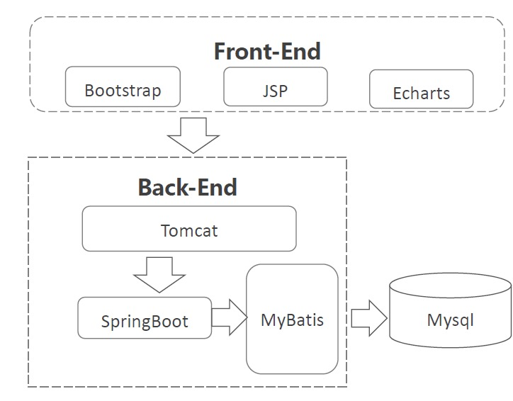

Entity Relationship Diagram
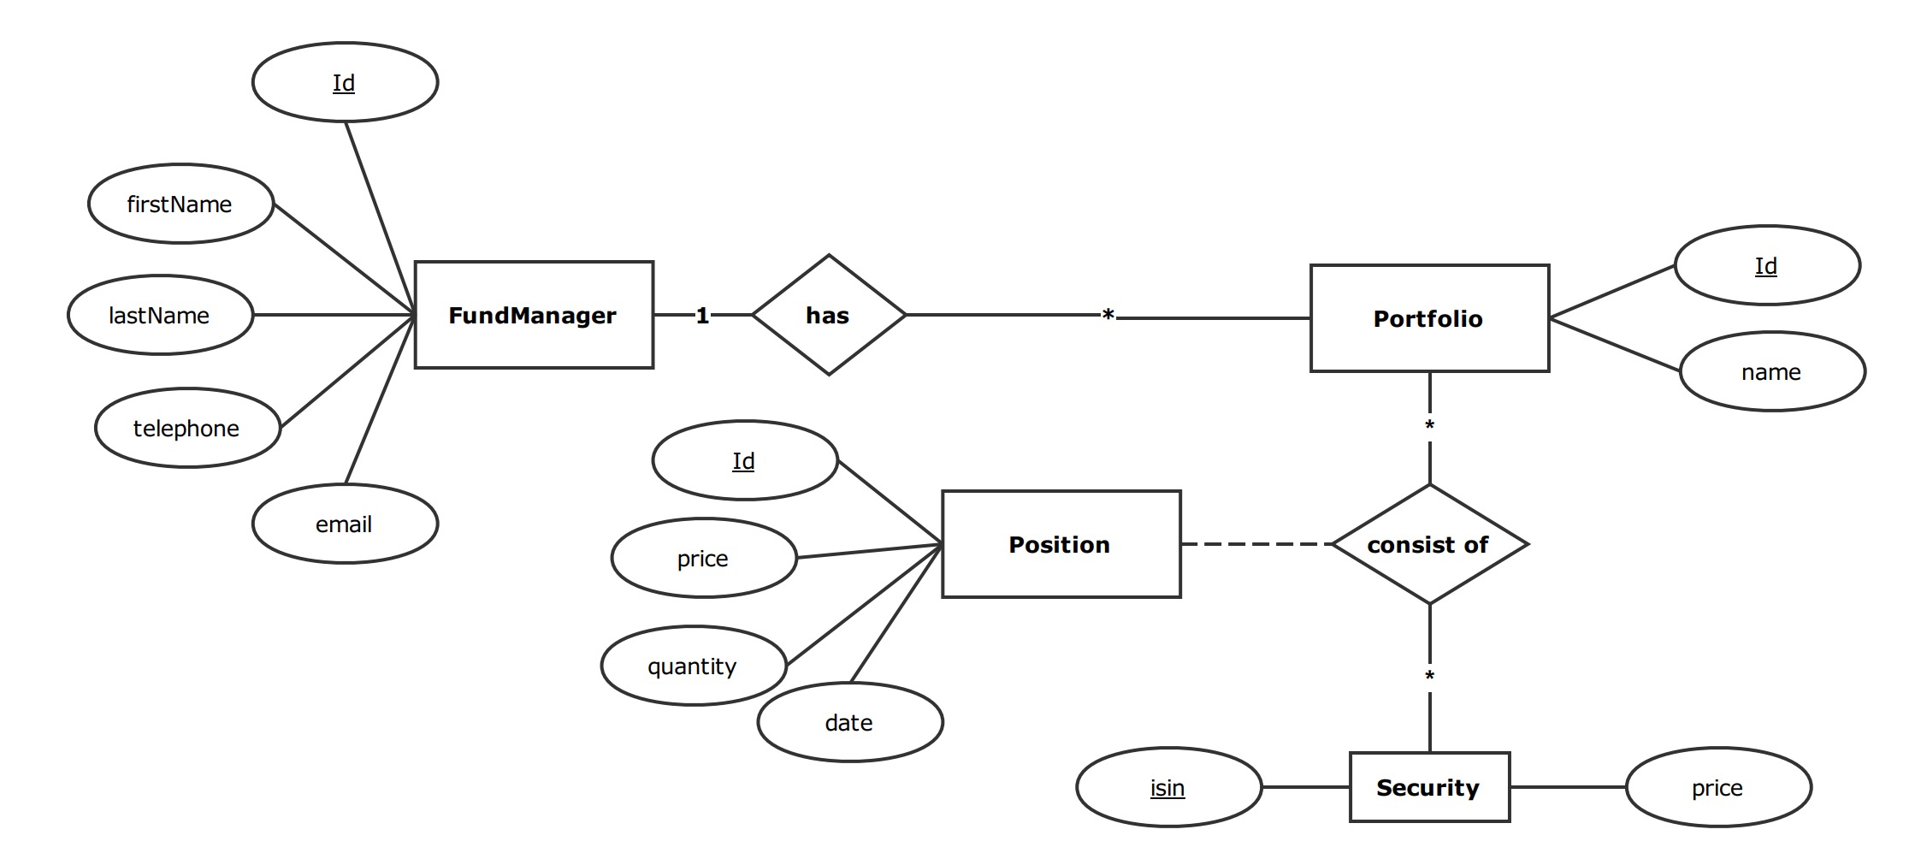

Development Plan
Time | Content | Staff
August 4th | Specification, Analysis, Design and Planning | All
7th August- August 10th noon | Delivery of Key Project Components | Front- Elaine, Demi  Server-Jeremy, Keira
August 10th afternoon | Integration and Testing | All
August 11th morning | Presentation & Demo Preparation | All
August 11th afternoon | Presentation & Demo to managers | All

